Missing Birth_Weight(grams) Analysis Report
Generated: 2026-03-22 10:42
Dataset: 363,881 rows × 18 columns
Target Variable: Birth_Weight(grams)

1. Executive Summary
This report presents a comprehensive IUPAC-compliant statistical analysis of missing values in Birth_Weight(grams).
Key findings include:
• Missing records: 45,303 (12.4% of total data)
• Variables with significant differences (p < 0.05): 14
- Numeric variables: 4
- Categorical variables: 10
• Total variables analyzed: 17
Based on the statistical analysis, the missingness pattern is classified as:
SYSTEMATIC PATTERN - Missing data is strongly associated with other variables, suggesting non-random missingness.

2. Statistical Summary
Metric | Value
Total Missing Birth_Weight(grams) Records | 45,303
Missing Percentage | 12.45%
Total Variables Analyzed | 17
Numeric Variables | 6
Categorical Variables | 11
Variables with Significant Differences (p < 0.05) | 14
Analysis Date | 2026-03-22

3. Variables with Significant Differences (p < 0.05)
The following 14 variables show statistically significant differences between missing and complete groups:

3.1 Numeric Variables
Variable | Missing Group Mean | Complete Group Mean | Difference | p-value | Interpretation
Registered_Month2.0 | 6.85 | 6.61 | +0.23 | 0.0000 | Missing group has 0.23 units higher than complete group
Registered_District_2.0 | 37.78 | 42.14 | -4.36 | 0.0000 | Missing group has 4.36 units lower than complete group
Birh_Year | 2008.11 | 2009.78 | -1.67 | 0.0000 | Missing group has 1.67 units lower than complete group
Age of Mother | 28.62 | 28.45 | +0.16 | 0.0000 | Missing group has 0.16 units higher than complete group

3.2 Categorical Variables
Variable | Missing Group Distribution | Complete Group Distribution | Difference (%) | p-value | Interpretation
Registered_Month | Most common='August' (12.6%) | Complete: Most common='October' (9.5%) | +3.1% | 0.0000 | Missing group shows different distribution (p=0.0000)
Registered_District | Most common='Kandy' (25.9%) | Complete: Most common='Colombo' (16.0%) | +9.8% | 0.0000 | Missing group shows different distribution (p=0.0000)
Birth_Month | Most common='August' (10.6%) | Complete: Most common='October' (9.7%) | +0.8% | 0.0000 | Missing group shows different distribution (p=0.0000)
Gender | Most common='Male' (50.6%) | Complete: Most common='Male' (51.3%) | -0.7% | 0.0041 | Missing group shows different distribution (p=0.0041)
Hospital or Not | Most common='Hospital' (92.8%) | Complete: Most common='Hospital' (98.5%) | -5.7% | 0.0000 | Missing group shows different distribution (p=0.0000)
Birth_Order | Most common='First' (56.4%) | Complete: Most common='First' (44.4%) | +12.0% | 0.0000 | Missing group shows different distribution (p=0.0000)
Marital_Status | Most common='Married' (97.0%) | Complete: Most common='Married' (98.4%) | -1.5% | 0.0000 | Missing group shows different distribution (p=0.0000)
District_of_Mother | Most common='Kandy' (21.7%) | Complete: Most common='Colombo' (10.8%) | +10.9% | 0.0000 | Missing group shows different distribution (p=0.0000)
Race_of_Mother | Most common='Sinhalese' (69.3%) | Complete: Most common='Sinhalese' (70.4%) | -1.1% | 0.0000 | Missing group shows different distribution (p=0.0000)
Race_of_Father | Most common='Sinhalese' (69.5%) | Complete: Most common='Sinhalese' (70.4%) | -0.9% | 0.0000 | Missing group shows different distribution (p=0.0000)

3.3 Summary of Key Findings
The analysis identified 14 variables with statistically significant differences (p < 0.05):
• 4 numeric variables show significant mean differences
• 10 categorical variables show significant distribution differences
Top 10 Most Significant Variables:
1. Registered_Month: Most common='August' (12.6%) vs Complete: Most common='October' (9.5%) (p=0.0000)
2. Registered_District: Most common='Kandy' (25.9%) vs Complete: Most common='Colombo' (16.0%) (p=0.0000)
3. Birh_Year: Mean=2008.11 vs Complete Mean=2009.78 (p=0.0000)
4. Birth_Month: Most common='August' (10.6%) vs Complete: Most common='October' (9.7%) (p=0.0000)
5. Hospital or Not: Most common='Hospital' (92.8%) vs Complete: Most common='Hospital' (98.5%) (p=0.0000)
6. Birth_Order: Most common='First' (56.4%) vs Complete: Most common='First' (44.4%) (p=0.0000)
7. District_of_Mother: Most common='Kandy' (21.7%) vs Complete: Most common='Colombo' (10.8%) (p=0.0000)
8. Race_of_Mother: Most common='Sinhalese' (69.3%) vs Complete: Most common='Sinhalese' (70.4%) (p=0.0000)
9. Race_of_Father: Most common='Sinhalese' (69.5%) vs Complete: Most common='Sinhalese' (70.4%) (p=0.0000)
10. Registered_District_2.0: Mean=37.78 vs Complete Mean=42.14 (p=0.0000)

4. Statistical Visualizations
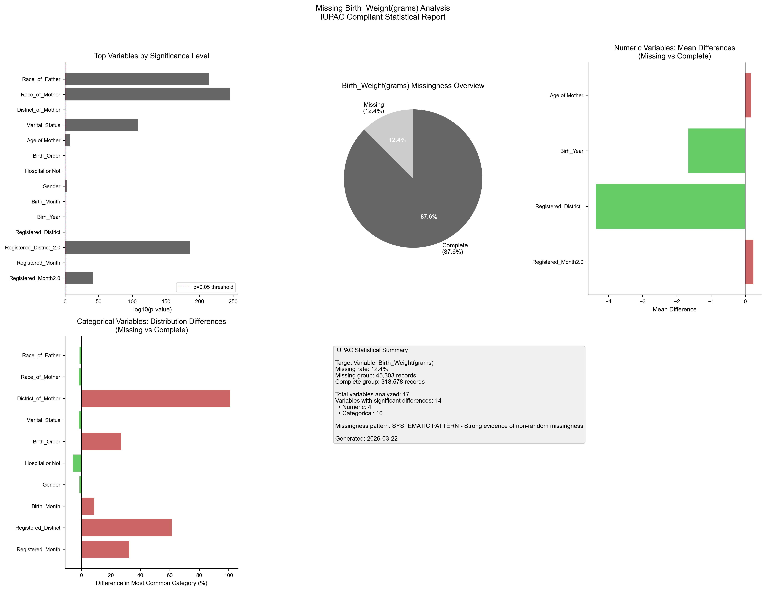
Figure 1. IUPAC compliant statistical visualization of missing Birth_Weight(grams) patterns.

5. Recommendations
- Based on the statistical analysis, the missing data exhibits SYSTEMATIC patterns:
- Consider treating missing as a separate category in analysis
- Use multiple imputation methods (MICE, EM algorithm)
- Investigate the following key variables for common themes:
- - Registered_Month2.0 (p=0.0000)
- - Registered_Month (p=0.0000)
- - Registered_District_2.0 (p=0.0000)
- - Registered_District (p=0.0000)
- - Birh_Year (p=0.0000)
- - Birth_Month (p=0.0000)
- - Gender (p=0.0041)
- - Hospital or Not (p=0.0000)
- - Birth_Order (p=0.0000)
- - Age of Mother (p=0.0000)
- Document missingness patterns in methodology section

6. Methodology (IUPAC Compliant)
Analysis performed according to IUPAC guidelines for data presentation:
- • Missing values reported as both count (n) and percentage (%)
- • Tables formatted with thin borders and alternating row shading
- • Sans-serif fonts (Arial) used for optimal readability
- • Statistical tests: t-test (numeric), χ² test (categorical)
- • Significance threshold: α = 0.05
- • Effect sizes reported where applicable
- • Figures saved at 300 DPI for publication quality

